SWE30009 Week 4 Tutorial

This is a practice question on identifying Metamorphic Relations by starting from the output information.
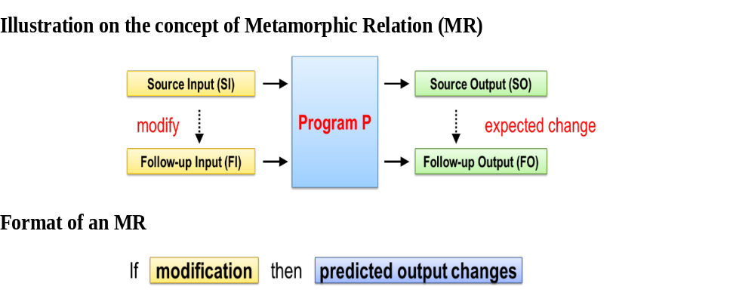
Consider a program which
- Accepts a list of integers as input
- Outputs the maximum integer of the input list
Suppose
- SI = [3, 9, -20, 16, 9, 7, -5, 28, 20, 5, -20]
- SO = 28
What kind of relationships are possible between SO and FO?

Relationship 1: | FO=SO
How FI should look like to achieve that relationship:
For every suggestion, try to provide examples of SI, SO, FI, FO to confirm
1 | If FI = SI + {x} where x = SI, then FO=SO  SI = [3, 9, -20, 16, 9, 7, -5, 28, 20, 5, -20]  SO = 28  FI = [3, 9, -20, 16, 9, 7, -5, 28, 20, 5, -20, 28]  FO = 28
2 | If FI = SI – {x} where x !=max (SI), then FO=SO  SI = [3, 9, -20, 16, 9, 7, -5, 28, 20, 5, -20]  SO = 28  FI = [3, 9, 16, 9, 7, -5, 28, 20, 5, -20]  FO = 28
3 | If FI = SI  SI = [3, 9, -20, 16, 9, 7, -5, 28, 20, 5, -20]  SO = 28  FI = [3, 9, -20, 16, 9, 7, -5, 28, 20, 5, -20] + [3, 9, -20, 16, 9, 7, -5, 28, 20, 5, -20]  FO = 28

Relationship 2: | FO<SO
How FI should look like to achieve that relationship:
For every suggestion, try to provide examples of SI, SO, FI, FO to confirm
1 | If FI = SI – k where k > 0, then FO=SO – k  SI = [3, 9, -20, 16, 9, 7, -5, 28, 20, 5, -20]  SO = 28  FI = [-2, 4, -25, 11, 4, 3, -10, 23, 15, 0, -25] (SI – 5)  FO = 23 (28-5)
2 | If FI = SI – all{x} where x = max(SI), then FO<SO  SI = [3, 9, -20, 16, 9, 7, -5, 28, 20, 5, -20]  SO = 28  FI = [3, 9, -20, 16, 9, 7, -5, 20, 5, -20]  FO = 20
3 | If FI = SI / k where k > 1, SI contains non-zero integers and divisible integers , then FI = SI / k  SI = [3, 9, -20, 16, 9, 7, -5, 28, 20, 5, -20]  SO = 28  FI = [1.5, 4.5, -10, 8, 4.5, 3.5, -2.5, 14, 10, 2.5, -10] (SI/2)  FO = 14 (28/2)

Relationship 3: | FO>SO
How FI should look like to achieve that relationship:
For every suggestion, try to provide examples of SI, SO, FI, FO to confirm
1 | If FI = SI  SI = [3, 9, -20, 16, 9, 7, -5, 28, 20, 5, -20]  SO = 28  FI = [3, 9, -20, 16, 9, 7, -5, 28, 20, 5, -20]  FO = 28
2 | SI = [3, 9, -20, 16, 9, 7, -5, 28, 20, 5, -20]  SO = 28  FI = [3, 9, -20, 16, 9, 7, -5, 28, 20, 5, -20]  FO = 28
3 | SI = [3, 9, -20, 16, 9, 7, -5, 28, 20, 5, -20]  SO = 28  FI = [3, 9, -20, 16, 9, 7, -5, 28, 20, 5, -20]  FO = 28

Relationship 4:
How FI should look like to achieve that relationship:
For every suggestion, try to provide examples of SI, SO, FI, FO to confirm
1
2
3

Relationship 5:
How FI should look like to achieve that relationship:
For every suggestion, try to provide examples of SI, SO, FI, FO to confirm
1
2
3

